

**BUSINESS CASES WITH DATA SCIENCE**

**MASTER DEGREE PROGRAM IN DATA SCIENCE AND ADVANCED ANALYTICS – MAJOR IN BUSINESS ANALYTICS**

**Business Case #4 – Recommender System**

Data4Business Consulting

Débora Santos, number: 20200748

Pedro Henrique Medeiros, number: 20200742 Rebeca Pinheiro, number: 20201096

May, 2021

i

**INDEX**

1. INTRODUCTION 1
2. BUSINESS UNDERSTANDING 1
   1. Background 1
   2. Business Objectives 1
   3. Business Success criteria 2
   4. Situation assessment 2
      1. Inventory of resources 2
      2. Requirements, assumptions, and constraints 2
      3. Risks and contingencies 3
   5. Determine Data Mining goals 3
   6. Project Plan 4
3. PREDICTIVE ANALYSIS 4
   1. Data understanding 4
   2. Data preparation 5
   3. modelling and evaluation 6
4. RESULTS EVALUATION 8
5. DEPLOYMENT AND MAINTENANCE PLANS 8
6. CONCLUSIONS 8
7. REFERENCES 9

# INTRODUCTION

Thank you for choosing **Data4Business Consulting (D4B)** to help you with the challenge of better understanding your customer's preferences. Our main objective is to help **Mind Over Data** to pass through a retail challenge in order to have a better understating regarding the point of sales appliance’s retail. With this analysis, we aim to answer questions about the top products sold, market share preferences and products co-ocorrences. The group also intend to provide clusters by the value and product preference and give the forecast demand six week ahead.

Despite the world experiencing a great technological and digital revolution, appliance retail’s sales still very popular once is a cultural behavior. The principal difference in this practice in the pass of the years, is that now customers are much more demanding with regard of quality, both services and products. So, understanding business data, customers, and their needs are essential for business success. Taking advantage of that, a continuous analysis is a fundamental strategy for any business to gain value, market share, and to stay relevant in the market. Consequently, the competition between sellers leads to a constant search for the improvement of their business models and decisions.

Through innovative technological programs, well-referenced data mining methods, and insights into digital marketing, the present report intends to provide an overview of the process behind the analysis, presents the results and insights you need to be successful.

In addition to the present report, the following deliverables will be submitted:

* + Outcomes presentation to Mind Over Data.
  + Jupyter Notebook with the code of the entire process. All files can be accessed in Github:

*https://github.com/Debs86/Business_Cases_Projects/tree/main/BC4.*

We are excited to take part in this challenge.

# BUSINESS UNDERSTANDING

* 1. **BACKGROUND**

**Mind Over Data** is an appliance’s retailer with 410 points of sales. The company works with 1535 brands products, which sells in total 8660 different products spread in the points of sales. The products are also divided in 178 products categories and 21 products families. In order to keep competitive, the company provided a dataset which contains sales history from January, 1, 2016 until November, 1, 2019 for analysis and further insights regarding the business.

Given the number of possible product choices available, is really important to have an understanding not only about the point of sales itself, but also about the products marketed, understanding their profitability over the years. Another important approach is comprehend customers behavior in specific periods, so that way, the points of sales can be prepared for different scenarios as a boost sales scenario and contacting suppliers or decrease sales scenario and then making an appropriate warehouse management. These analyses have become a very important part of the retail industries, by providing an assertive overview about products or services which hopefully increase sales and reduces damages.

.

* 1. **BUSINESS OBJECTIVES**

The customer’s primary objective is to build models to answer the following problems:

* + Understand each Point-of-Sale characteristics (top products sold, market share preference, product co-occurrences.)
  + Points of sales clustering divided by value and product preference.
  + Units’ products forecast 6 weeks ahead.
  1. **BUSINESS SUCCESS CRITERIA**

The main expected outcome will be providing analysis about the business in general but in a different aspect. Regarding the Points of Sales, reports will be given in order to answers questions mentioned about their particularities, considering the products marketed in it.

Another expected outcome will be well defined points-of-sales’ clusters which can make possible to build a customized marketing strategy and maximize the return of investment, once providing this segmentation is possible to have a better understanding about customer behavior.

And least, a 6 week forecast demand ahead making possible to the point-of-sales be well prepared considering the sales history provided.

* 1. **SITUATION ASSESSMENT**

## Inventory of resources

This project was made following the CRISP-DM reference model (Cross Industry Standard Process for Data Mining). CRISP-DM is a standard process built at the end of the ’90s and it was built by more than 200 members lead by a consortium of big companies. *CRISP-DM succeeds because it is soundly based on the practical, real-world experience of how people conduct data mining projects.*[2]

This project has the support of Mind Over Data Management and staff.

On the D4B Consulting side, this project will be conducted by a team of 3 Data Scientists and Business Analysts.

We have been provided by the Mind Over Data team with a dataset with transactions of customers occurring between January 1, 2016 until November 1, 2019. Along with this dataset, its metadata file was also provided.

The main technology used to achieve the objectives of this report was Python. Python is one of the most important and commonly used program languages in data science projects. The main packages for recommender systems are surprise and implicit. As we are dealing with implicit data, the package used in this work was implicit. We also used sklearn to evaluate the models and scipy to create the sparse matrices.

## Requirements, assumptions, and constraints

The completion date of the present phase of the project is May 03, 2021, but we expect to continue giving support and helping MGUK to achieve the next goals for the growth of the business.

Recommendation systems are divided into two main categories:

1. Collaborative filtering utilizes the past data of user’s interactions as well similar choices made

by other users. “Similarity” is measured against the similarity of users. *[3]*

1. Content-based filtering uses the knowledge about each product to recommend items with similar properties. “Similarity” is measured against product attributes*. [3]*

In a collaborative filter, the system can find similarities based on purchase history but also based on demographic data. One of the constraints of this project is the lack of demographic data. It is not a mandatory requirement, but it would improve the quality of the recommendations. Examples of demographic data are genre, age, and location.

In addition, it would also not be possible to find similarities based on product attributes as the data does not provide details of products only code, and name.

Regarding the type of data, recommender systems make use of two types of data: Explicit or implicit. These concepts will be explained later in the section terminology. On this project, we only have implicit data available.

## Risks and contingencies

Table 2.1 identifies a list of risks and contingencies proposed.

|  |  |
| --- | --- |
| **Risk** | **Contingency** |
| Insufficient features of customers’ behaviors/ characteristics | Work with remaining features |
| Insufficient product attributes | Work with remaining features or ask for different variables |
| Only one year of transaction data and a peak sale in November. | Ask for more observations (transactions) |

Table 2.1 - Risks and contingency.

## Terminology

### Business glossary

Point of sales appliances retail usually have as principal business glossary:

* + SKU: Related to the unique stock code for each product marketed. For each product is assigned a different SKU for warehouse management according to the product attributes. The code is also crucial for sales tracking.
  + Point-of-sale: Where transactions can be completed and the customer can pick up the product desired. To operate a point-of-sale, many activities must be done as administrative, management, marketing, maintenance, stock, and so on. Considering that each business is very singular, most point of sale has their on system assuring that the transactions can be done and also connecting supplier-bussiness-customer.

### Data mining glossary

* Clustering: It is a data mining technique. The technique consists in apply some algorithms that will classify the observations (customers) into groups according to the similarity of their attributes.
* Normalization: The major algorithms of clustering need the data be scaled to a standard range. The process of applying some transformations in the data to have it in the same range is called normalization.
* Forecast demand: Related for predicting the future demand in the retail products. It is anticipating the product desire considering both controllable and uncontrollable effects. Improving forecast demand accuracy the business will be able to make assertive decisions regarding inventory, marketing, warehouse and others.
* Accuracy:
* Precision:
* F1-score:
* AUC:
  1. **DETERMINE DATA MINING GOALS**

The data mining goals states project objectives in technical terms:

1. Create a model that will be able to segment point of sales according to the customers products preferences.

*Success criteria*: The TNSE (visualization technique to visualize the distribution of the clusters) must have a good distribution of the clusters; Also compare the R2 metric of some cluster techniques applied and chose the one with the highest R2.

1. Create a model that will be predict forecast demand.

*Success criteria*: High percentages of accuracy, precision, F1-score and AUC.

* 1. **PROJECT PLAN**

Business understanding

0.5 day

Data understanding

1.5 days

Data preparation 2 days

Modelling

2.5 days

Evaluaton 1 day

Deployment 1 day

Figure 2.1 - Project’s timeline.

Resources wise, for the business understanding we plan to use all the information provided in the kickoff meeting’s presentation. For the core stages of the project, we plan to use Python to work the data provided. To present the results, we expect to use Word for the report and Powerpoint for the presentation.

The performance of the model will be directly connected with the quality of the input data. For this reason, we identify the Modelling stage as dependent on the Data preparation stage. During the project, we must go and back between Data preparation and Modelling many times, repeat this iteratively until we get the desired outcome.

For the Modelling stage, we aim to build a matrix factorization model using Alternating Least Squares algorithm. We opted for this model because it presented the best results compared with other algorithms. Further details will be presented in section 3.3 – Modelling and evaluation. The model evaluation will be made using Area Under the curve (AUC).

# PREDICTIVE ANALYSIS

In this section, we go through the process of understanding and preparing the data for modeling, the modeling itself, the different algorithms used, and, finally, the evaluation of the results.

* 1. **DATA UNDERSTANDING**

At this stage, we analyzed the dataset to understand its potential and limitations. First, we looked at the data in the excel file to check inconsistencies. The data understanding step is good to understand what variables are in the dataset, what they mean, the number of variables (10 features, from which 7 categorical and 3 numerical as shown in Table 3.1) and observations (xxxx purchase transactions), if there are inconsistencies, if there are missing values (there were any) and/or duplicated values (106).

We have also looked at the metadata file provided to understand the meaning of each feature to understand their relevancy in the project.

|  |  |
| --- | --- |
| **Numeric** | **Categorical** |
| *Quantity, Sales Values, Avg price* | *ProductFamily_ID, ProductCategory_ID, ProductBrand_ID, ProductName_ID, ProductPackSKU_ID, Point-of-Sale_ID, Date* |

Table 3.1 - Numerical and categorical features.

The dataset is composed of xxxx transactions, 410 point-of-sales, 21 Families Products, 178 Categories Products, 1535 Brands Products, 8660 SKU.

Going into more details, September to November are the months where there is a higher volume of sales (Figure 3.1). Most customers have only one invoice and few of them bought more than 15 times (Figure 3.2).

The cancelations transactions represent 1,7% of the total transactions. Also, transactions without a

*CustomerID* represent almost 25% of the total transactions.

More than 80% of the sales volume coming from United Kingdom customers (Figure 3.3).

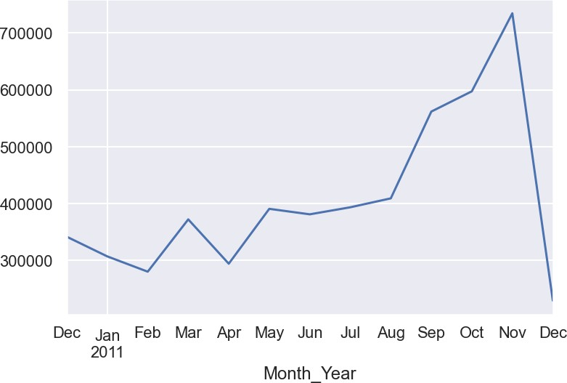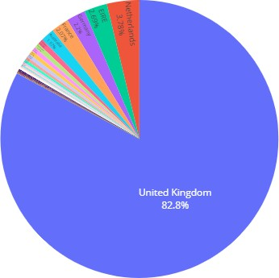

Figure 3.1 – Volume sales by month Figure 3.3 – Sales volumes by country

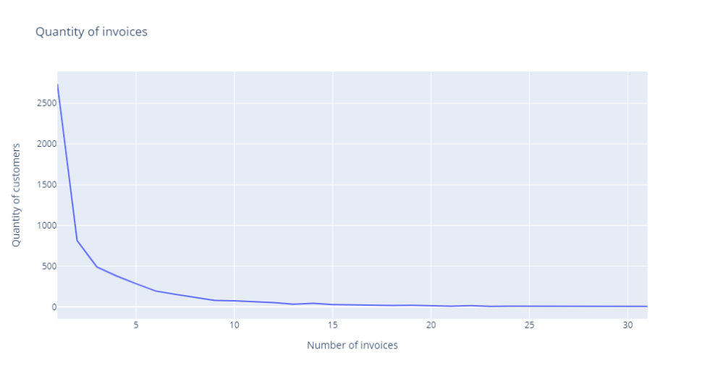Figure 3.2 – Number of Invoices vs. Number of customers

* 1. **DATA PREPARATION**

At this stage, the dataset should be prepared to ensure a good quality of the data to the algorithms achieve good performance.

On the first step of data preparation, we removed duplicate observations. Next, we eliminated all observations whose *StockCode* does not fit with the described format on the metadata (“Nominal, a 5-digit integral number uniquely assigned to each distinct product”). Therefore, we only keep the observations whose *StockCode* is 5 numbers, and the only exception that was made is that we also keep *StockCode* with 5 numbers followed by one letter. We also remove the remaining observations with a price equal to 0. Regarding these last 2 inconsistencies (stock code and unit price), we could

verify that most of the transactions are about adjustments, post and amazon fees, damages, and others that could not be used by a recommender system. We removed 2% of the data until this step.

The next step was feature engineering which we built 1 new feature, for data analysis purpose:

|  |  |
| --- | --- |
| **New variables** | **Description** |
| *Month_Year* | *Month and Year related to that transaction.* |

Table 3.2 - New variables.

After these changes, the missing descriptions were already dropped. For the missing *CustomerID*, we applied two approaches: For a better understanding of the data, we create a fake *CustomerID* for each observation, according to the invoice number. Observations with the same *InvoiceNo* have the same *CustomerID*. The algorithms for the recommender system work with datasets in a matrix format. For the recommender system purpose, we drop all the observations without CustomerID. Regarding the recommendations to them, we are going to make recommendations in the same way we are going to make to new customers as we do not have a track of their transactions.

* 1. **MODELING AND EVALUATION**

In this step, we are going to fit the algorithms for the recommender system.

The first stage of this process was to reduce the sparsity of the data. As we have a big dataset, for a better performance of the model, we must have only transactions that matter. Transactions related to customers or items without significant history were removed from the data.

In the next stage, we created a new dataset only with the columns that the algorithm will use: *CustomerID*, *StockCode,* and *Quantity*, grouped by *Quantity*. All observations where the sum of quantity was 0 were removed from the dataset.

As we stated before, the data used in this work is implicit. Also, we are going to use a collaborative filtering approach as we are dealing with past data of purchases of the customers. To have a better performance of the algorithm we still need to solve the problem of our data having many different dimensions, but we need to compile them in few dimensions. In other words, the many clicks of one user in a website just express a couple of tastes, or any purchases of an item express only some tastes. To solve that, there is a technique called matrix factorization that works to reduce the data dimensionality transforming the original data “all users by all items” matrix into two small matrices much smaller that represents “all items by some taste dimensions” and “all users by some taste dimensions”. These dimensions are called latent or hidden features and it is learned from the data. This dimensionality reduction makes the work much more computationally efficient, brings better results because it is working in a more compact space and it also allows us to find connections between users who have no specific items in common but share common tastes*. [4]*

Therefore, the third stage of this step was applying some transformations on the data to have 2 matrices: one for fitting the model and the other will be used to make recommendations. The column quantity was used as a measure of the level of confidence. If the customers buy a large quantity of a product, it means that he really liked that item.

The last stage before fit the model was to split the data into train and test datasets. In this case, the split is done by making a “mask” of the data. The test size contains all original data, and on the training set, 20% of the data is replaced by zeros.

Now that we have our data in the required input format, we applied 3 different algorithms: Alternating Least Squares (ALS), Bayesian Personalized Ranking (BPR), and Logistic Matrix Factorization (LMF) with the following parameters:

|  |  |  |
| --- | --- | --- |
| **Parameters** | **Description** | **Values** |
| *Alpha* | *Used to reflect the importance of confidence [5]* | *15* |
| *Factors* | *Number of latent factors.* | *20* |
| *Regulation* | *Regularization to avoid overfitting* | *0.1* |
| *Iterations* | *Number of iterations to fit the model* | *50* |

To measure the performance of each algorithm, we used a function that calculates AUC (explained in section 2.4.3.1) for each user that had at least one item masked on the train set and later calculated the average AUC of all users. This function also allows a comparison with the AUC of the most popular items for all users.

The results are presented in Figure 3.4.

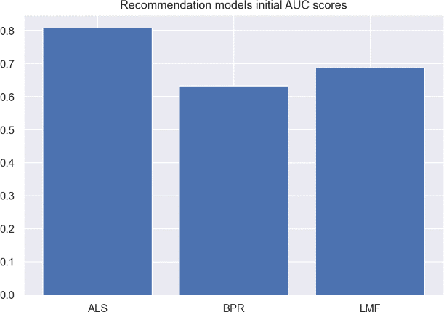

Figure 3.4 - Models score.

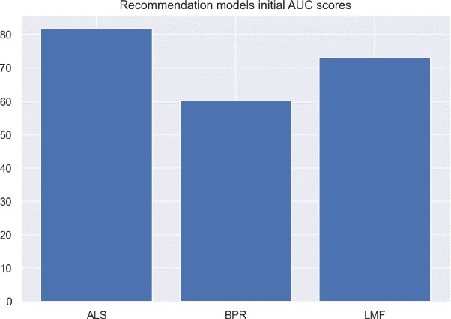The next stage was trying to improve the scores by tuning the parameters. We create a function to tunning the parameters and show the parameters that should be used for the best results. The details with the parameters tuned can be found in the notebook. The table with the best parameters of each model and the graphic with the results are presented below:

|  |  |  |  |
| --- | --- | --- | --- |
| **Parameter** | **ALS** | **BPR** | **LMF** |
| Alpha | *15* | *20* | 40 |
| *Factors* | *50* | *40* | 60 |
| Regulation | *0.1* | *0.01* | 0.05 |
| *Iterations* | *40* | *60* | 50 |

Table 3.3 - Tuning RF parameters and results.

The model with the best performance was Alternative Least Square. Therefore, the recommendations will be made using this algorithm.

Finally, we created 2 functions to make sure the good performance of the algorithm by checking its recommendations. The first function is to find similar items given an item. The second function is to make recommendations to a customer and compare the recommendations with the most items bought by that customer. The results can be found in the notebook.

# RESULTS EVALUATION

The model developed by B4C reached good values and will certainly help Many Gifts the UK to implement recommendations to your customers and help them to make better choices.

The recommender model predicts recommendations correctly 81,7% of the time. It will probably lead to an increase in sales, which was stated as one of the business goals.

The next step will be implementing the recommender system on the homepage of your website.

Regarding the cold start problem, in this first stage, we created a function that recommends items for new users according to their country. The recommendations will be done according to the last two months' purchases of other users based on the same country of the new customer. It will also be implemented on the MGUK website.

# DEPLOYMENT AND MAINTENANCE PLANS

We understand that the process of implementing the recommendation system is very critical to your business. Retails shops market is very dynamic and every day, there are new purchases on the system. So, we understand that it would be very important to implement the analysis provided integrated with the purchase system. Integrating both, the recommendations will be updated on a daily basis and it will improve the customers’ choices.

Another important point is that we would like to make some suggestions. We suggest to MGUK to improve the items data. It would be important if we have more attributes regarding items to facilitate the recommendation based on the similarity of items. The second suggestion is about data collection from the customers. As we stated before, from explicit data we knew if the customer liked or disliked an item. It would be very interesting if you could get ratings from your customers about the items purchased. Another interesting information about a customer to collect is regarding their preferences: kind of items they are interested in for example. It would also help in the cold start problem.

We are going to monitor the performance of the model after it is implemented for some months and make some adjustments if necessary. Also, if the suggestions above were implemented, we could improve the recommendation models. But it is not mandatory.

We also suggest updating the model from time to time as the behavior of the customers, and even the market trends, can change, reducing the model performance.

Lastly, considering this model was built with only a few thousands of observations, we consider that re-training the model, when new data is available, would potentially improve its quality.

# CONCLUSIONS

As state in section 2.2 – Business objectives, the main objective of this project was to implement a predictive model to make recommendations for old and new customers.

The model developed by B4C reached good values on many important measures such as 81,7% of AUC, which means the model will predict the right recommendations 81,7% of the time. It would certainly help customers make better choices and probably increase sales volume.

In addition, we set some risks on this project. One of these risks is the model performance, as we have been working with only one year of the data. We implemented some actions to reduce this risk, but the model will have an improvement margin if we get additional datasets to test its performance.

We hope ManyGiftsUK is satisfied with D4B work and we can continue working together.

# REFERENCES

1. Hu, Y., Koren, Y., Volinsky, C.. Collaborative Filtering for Implicit Feedback Datasets.
2. Chapman, P, Clinton, J, Kerber, R., Khabaza, T., Reinartz, T, Shearer, C. & Wirth, R. (2000). *CRISP-*

*DM 1.0*, CRISP-DM consortium

https://www.softwareadvice.com/resources/what-is-a-point-of-sale-system/